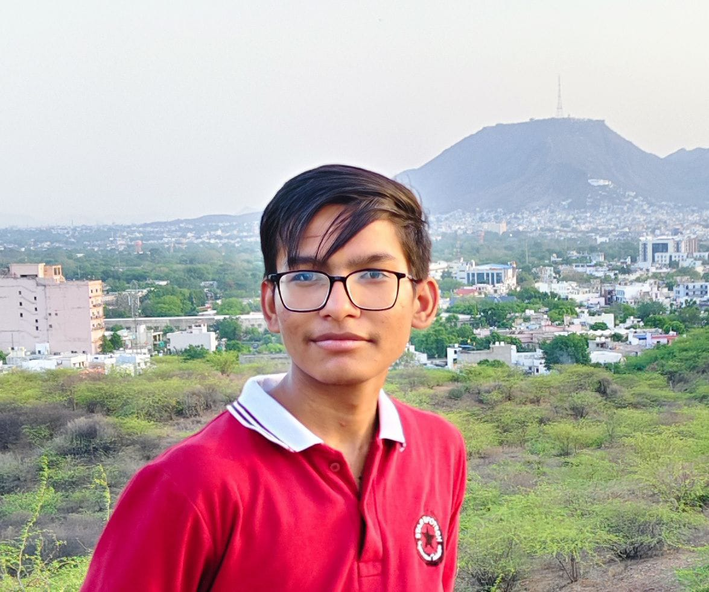

**Chetan Sahu**

Financial Advisor

**Email:** pradeepsahu00275@gmail.com

|  |  |
| --- | --- |
| **Address:** | **Mobile:** +91 9610063383 |

**SKILLS:**

* **Programing Languages:**

**C, C++, JavaScript, Python,Ruby**

* **Web Development:**

**HTML, CSS, Bootstrap**

* **Operating System known:**

**Windows & Linux**

**STRENGTH:**

* **Leadership**
* **Communication Skills**

**EDUCATION:**

**● Bachelors of Computer** **Application (BCA)**

Star Infotech College, Ajmer Rajasthan

(2023-present)

● **High School Study(Class 12th )**

Tak Global Academy, Ajmer Rajasthan (2023)

● **Secondary School Study(Class 10th )**

Tak Global Academy, Ajmer Rajasthan (2021)

**LANGUAGES KNOWN:**

* Hindi
* English

**CAREER OBJECTIVE**